
Business Requirements Document
Trifecta Projects Pvt. Ltd.



Business Requirements Document

By

Fingertip Technologies Pvt. Ltd

Document Control Information Document Information

Document Name | Post Sales
Project Name | Trifecta Projects Pvt. Ltd. Release-2
Client | Trifecta Projects Pvt. Ltd.
Document Author | Anusha Koppera
Document Version | 5
Document Status | Revised and Submitted
Date Released | 06/02/2026
Contact Person | Ms. Anusha, +91-9538117552

Sign-off Index
Document shared on | Document Approved on | Version
23.12.2025
23.01.2026
06.02.2026 | 09.02.2026 | Version 4.0
20.03.2026 |  | Version 5.0

Introduction

Key Definitions

Term | Definition
Object | Objects are database tables that allow to store data specific to an organization in salesforce. e.g. Lead is an object; Booking is an object etc.
Record | A record is data entry on an object and consists of collection of data in fields, possibly of different types, typically in fixed number and sequence.
List View | List View allows user to see a filtered list of records
Layout | Page layouts control the layout and organization of buttons, fields, and related sections on object record pages. They also help determine which fields are visible, read only, and required.
Setup | Setup is a section of the Salesforce interface where users can configure and administer the system.
Sandbox | Sandbox is a copy of an organization's production environment that is used for testing and development.
Profile | A set of permissions that determine what a user can do within the Salesforce platform. Profiles define the actions a user can perform, the objects they can access, and their system-level permissions.
Apex Log | A system object that stores detailed information about the execution of Apex code, including details like database operations, system processes, errors, and debug messages, allowing developers to track and troubleshoot their custom Apex code within the Salesforce platform

Post Sales Process

Important Notes:
- For villa projects there will be 2 documents 2 different companies TRIFECTA INFRA PVT. LTD. And TRIFECTA PROJECTS PVT. LTD. And demand will be different for land and construction.
- The extra amount no need to adjust in the demands it should be carried forward till the registration This needs to be carried forward till the registration, as it will be the interest amount which the customer has to pay for delaying, the payment. We cannot remove the penalty till the handover is given as any time can send the penalty for the delayed payments starting from Booking.
- Provision to add the progress during the demand is sent.
- Provision to send the project status “bulk” and individually For apartment only option will be given to send bulk, but for villa project status needs to be sent individually. Project status can be sent without raising demand also.
- For all the emails “CC” to be done for CRM manager and CRM executive No limitation
- Emails to be sent for applicant and Co applicant “To”
- Approval is required for cancellation from the CRM head
- Refund record needs to be created by the CRM executive and request will be sent for finance dept.
- Post sales also need option for calling from salesforce it self. CRM executive can navigate to the lead detail page and can click on “Call Customer” Button.
- For post sales Number masking is not required

Table of Contents
- Key Definitions
- Roles of Users
- Post Sales Process Flow
  - Objective
  - Scope
  - High-Level Process Stages
  - Detailed Functional Flow
- Reporting & Dashboard Requirements
- Appendices

1. Key Definitions
Object: Database tables to store data specific to an organization in Salesforce (e.g., Lead, Booking, etc.)
Record: Data entry in an object consisting of multiple fields.
List View: A filtered view of records.
Layout: Organizes the display of buttons, fields, and sections.
Setup: Section of Salesforce used for configuration and administration.
Sandbox: A testing and development replica of the production environment.
Profile: Permissions determining user actions and object access.
Apex Log: Stores execution details of Apex code for debugging.

2. Roles Hierarchy
- Management User
- CRM Head
- CRM Manager
- CRM Executive

3. Post Sales Process Flow

Objective
To define and document the complete post-sales process from unit booking through to handover, including payment collections, agreements, registrations, cancellations, and customer service.

Scope
- Booking creation & validation
- Agreement execution
- Payment scheduling & collections
- Cancellations
- Progressive demand management
- Registration & possession
- Complaint handling
- Reporting & dashboards

High-Level Process Stages
- New Booking
- Agreement Execution
- Demands & Collections
- Registration
- Possession/Handover
- Maintenance
- Cancellation (Before & After Agreement)
- Customer Service & Complaints
- Reporting & Dashboards

Detailed Functional Flow
- New Booking
  - CRM head will define the CRM executive tower wise, from next stages CRM manager will assign CRM executive manually based on the work load.
  - Initial booking stage will be always handled by 1 executive only
- Agreement Execution
  - Agreement executive will be selected by CRM manager and booking is transferred to selected executive.
  - Agreement stage will be always handled by 1 executive only
- Demands & Collections
  - Demand & collection executive will be selected by CRM manager and booking is transferred to selected executive.
  - Demand & collection stage will be always be handled by 1 executive only
- Registration
  - Registration executive will be selected by CRM manager and booking is transferred to selected executive.
  - Registration stage will be always handled by 1 executive only
- Possession/Handover
  - Possession executive will be selected by CRM manager and booking is transferred to selected executive.
  - Possession stage will be always handled by 1 executive only
- Cancellation (Before & After Agreement)
  - CRM Manager will only have the access to request for the cancellation approval process
  - CRM executive can click on button “Request for Cancellation”. This is intimation for CRM manager to initiate the cancellation process
  - 1 Level Approval process.
  - APPOVAL HIERARCHY: CRM MANAGER CRM HEAD
- Customer Service & Complaints Maintenance stage also is covered as part of this stage only
  - Customer Service & Complaints executive will be selected by CRM manager and booking is transferred to selected executive.
  - Customer Service & Complaints stage will be always handled by 1 executive only
- Customer Service & Complaints stage will be always handled by 1 executive only
- Reporting & Dashboards

Important Notes:

- Option to add the blank template if required Blank Email template will be provided where user will select the blank template and send to customer using the salesforce standard activity button “Send Email”.
- All email notifications and reminders email needs to be followed as per real estate standard
- In each and every stage CRM executive need to check the stage completion check box. Once the checkbox is true notification will be sent to CRM manager regarding completion of the particular stage.
- CRM manager can update the current stage and assign the CRM executive to the Next stage.
- Swapping: In case of swapping, All the process needs to be followed as mentioned below
- Quotation Booking Management Approval Push To CRM Assignment to CRM executive based on tower Closed
- Old booking will be marked as cancelled and cancellation process will be followed as mentioned in the cancellation stage
- Receipt for the old booking will be marked as “Cancelled”
- New receipts and co applicants will be created again under the New booking
Access:
- Once the stage is completed by the respective executive. Executive can update the completion of the stage.
- CRM Manager will be notified regarding the same
- CRM Manager can now assign the next stage to another executive manually
- Once the next stage is assigned with the new executive, previous executive will loose the edit access to the booking. Where as Read access will retain same
- Example:
  - Executive 1 is assigned with Booking stage
  - Executive 1 completed the booking stage
  - CRM manager will next assign the Agreement stage to Executive 2
  - Now the Executive 1 will have only Read access to the booking record including related records
  - Same process is applicable for all stages executives.
- CRM Manager can now assign the next stage to another executive manually

Stage 1 – New Booking
Document Generation:
- Booking form
- Receipt Receipts created by CRM executive will be auto approved and will not be sent for any approval process.
Trigger: Customer confirms purchase decision.
Process Steps:
- Initiate Booking
  - Sales Executive clicks Create Booking in CRM. From quote object
  - Fill required fields in booking popup.
- Booking Advance Collection
  - Collect 10% advance. Booking amount can be of customer choice and remaining amount will be adjusted under the 1st payment milestone accordingly based on payment
  - Select Funding Type: Loan or Own Funds.
    - If Loan: Bank Name & Loan Status mandatory.
- Applicant Details
  - Capture details for 1st & 2nd applicant and can add more applicants if required
  - Upload KYC documents.
- Update Unit Status → Booked
- Automatic Receipt Generation
- Approval Process for receipt All receipts will be auto approved on default basis once created by CRM executive.
- Generate Booking Form (PDF auto-filled from system).
- Email Booking Form to customer. Customer will receive the booking form details, but customer will not be able to approve or reject via mail. This is excluded as part of the demo meetings intimation by Trifecta Team
- Once booking is created by Sales executive and clicks on “Push To CRM” and post Management approval.
- Booking will be assigned to 1st CRM executive based on the executives defined Block wise (Ex: A, B, C)
- Admin can define the CRM executive BLOCK WISE
- Welcome Email (within 48 hrs, Executive can send manually) with: If the Mail or call is not made by CRM executive within 48 hours. Manager can view the report with the bookings due for welcome call and welcome email
  - Payment receipts
  - Cost sheet
  - Next payment demand letter (Based on Defined percentage% for agreement on project level for 1st payment milestone)
  - Store in CRM record.
  - In case of villa project need to send TDS and stamp duty charges
  - Apartment: TDS will be included on salesforce on booking form and stamp duty charges can be excluded on the salesforce
  - After the booking amount is paid completely then only welcome email will be sent by user manually and if the payment is not made also user can send welcome mail
  - For advance amount finance approval is not required but notification will be sent for fiancé department.
- Welcome Call (within 48 hrs) by CRM executive.
- Welcome Call Checklist completed
Business Rules: For agreement execution payments
- Agreement Reminder after booking with in 21 days agreement need to be made, Agreement date will be updated based on the booking date.
- CRM Executive can enter the expected Agreement Date manually. Reminders will be sent based on the 1st demand raised date.
  - Reminder 1 → Day 10 before payment due date. Email Reminder
  - Reminder 2 → Day 15 before payment due date. Email Reminder
  - Reminder 3→ Day 18 before payment due date. Email Reminder
  - Cancellation charges 25000/-
- Termination process Termination acceptance/Unit unblocking: Once the termination request is approved by CRM Head automatically the unit will be unblocked and unit will be available for sales inventory.
  - CRM Manager can trigger emails manually
  - Termination email → CRM Manager can send termination mail to customer manually by clicking on the button “Send Termination Email”
  - Termination and cancellation process is one and the same for the booking

Stage 2 – Sale Agreement Execution

Document Generation:
- Sales agreement (static )
- TPT Only 3 banks TPT will be generated | TPT is excluded from salesforce

- Validation: Till the agreement date edit of the applicant details will be allowed and once the stage is marked as “Agreement completed” edit for the details will be not allowed
- During Agreement TDS handling will be part of the salesforce
- If it is apartment or row house it will be (1%)
- In case of villa: 1% for the land and 2% for the construction
- Email and Phone number of the applicant details needs edit option always.
- Agreement date extension approval request will be sent to the CRM Head along with extended date by CRM executive
- Once approved by the CRM Head agreement date will be extended.
- Based on the agreement date, before 1 week one more email reminder will be sent
Trigger: 20% payment milestone reached (Defined percentage)
NOTE: CRM Executive will not have the have option to edit the payment changes in the Sales Force post the booking
Process Steps:
- Draft Agreement prepared after 10% booking payment.
  - Villa Booking amount is 5,00,000/-
  - Row House booking amount is 3,00,000/-
  - Flat booking amount is 2,00,000/-
- Follow payment reminder cycle (same as Stage 1).
- Scan signed agreement & upload to Salesforce.
Termination Rules (Same as Termination process):
- Payment not received despite reminders.
- Customer not attending agreement process

Stage 3 – Cancellation

A. Before Agreement
- CRM Manager will only have the access to request for the cancellation approval process
- CRM executive can click on button “Request for Cancellation”. This is intimation for CRM manager to initiate the cancellation process
- 1 Level Approval process.
- APPOVAL HIERARCHY: CRM MANAGER CRM HEAD
- Customer fills Cancellation Form excluded from salesforce only email will be sent by CRM manager manually
- Apply cancellation charges (editable with approval).
- If the cancellation amount is less than 25000/- then CRM manager needs approval from CRM head, post approval it will be processed.
- If the cancellation amount is 25000/- no need of approval process.
- Once the cancellation request is approved by CRM Head automatically the unit will be unblocked and unit will be available for sales inventory.
- CRM Manager can Create Refund Record: refund date, amount, payment mode, bank details, reason.
- Allow refund entry post-cancellation if not immediate.
- Notifications:
  - CRM executive click on button “Request For cancellation”
    - Notification to booking sales user
    - Notification project sales head
    - CRM manager

B. Post Agreement
- CRM Manager will only have the access to request for the cancellation approval process
- CRM executive can click on button “Request for Cancellation”. This is intimation for CRM manager to initiate the cancellation process
- 1 Level Approval process.
- APPOVAL HIERARCHY: CRM MANAGER CRM HEAD
- All post agreement cancellation request will be sent to CRM Head
- CRM manager raises cancellation request → Approval by CRM Head
- Apply 10% cancellation charges
- Once approved by the CRM head, CRM manager can manually update the unit status as Available, History tracking will be enabled
- CRM Manager can manually click on button “Send cancellation mail” and cancellation agreement will be attached.
- Refund within 90 days.
- Manager can manually Upload Cancellation Agreement against booking record.
- Mark if cancellation agreement collected.
- Notify Finance → Provision for creating Refund record will be given to CRM Manager
- Notifications:
  - CRM executive click on button “Request For cancellation”
    - Notification to booking sales user

    - Notification project sales head
    - CRM manager

Stage 4 – Demands & Progressive Collections
Trigger: Construction milestone completion.
Process Steps:
- Project CRM Manager can update milestone status as “completed” and completion date (by opening the Block specific project master payment schedule record)
- CRM manager can send Project Status Report (PSR) with photos to customers.
- Notify CRM Executive who is added for demands & collections stage.
- Instead of System automatically sending demand, executive can manually click on button “Raise Demand” from respective booking record
- Generate bulk (Applicable for only CRM manager) or individual demands: Bulk is applicable for apartment only and for villa and row it will be individual
- Option to exclude few customers during bulk demand raise will be provided
- Can videos be attached Video can be attached for project status report. Limit of the video should be 3 MB
- Whenever Bulk raise demand button is clicked on below mentioned columns will be displayed for reference
  - Booking ID
  - Customer Name
  - Unit Number
  - Flat cost
  - Pending previous demands
  - Interest: Apartment 12% Row House 12% , Villa 18%
  - Current milestone amount
  - Total due + due date
- Send demand letter via email & store in Salesforce.
- Villa: CRM executive can manually generate individual demands with milestone selection.
- Without the demand also CRM executive will be able to send the Project status to the customers via mail, option will be there to send individually
- CRM executive can generate and share with customer below mentioned templates
  - Revised Demand Note (Milestone): When the demand is raised, if there are pending payments from customer template contains current milestone amount and previous due amount and interest amount also if applicable. In this scenario user will have the option to include or exclude the interest amount in the payment schedule.
  - Penalty Demand Note: This will contain current demand amount, Revised Amount and Penalty (Interest amount). Template is prepared as per the client format only.
Payment reminders:
  - Reminder 1 → 6th day, post the demand is raised
  - Reminder 2 → 8th day, post the demand is raised
  - Reminder 3 → Final reminder on 10th day, post the demand is raised

Business Rules:
- Interest calculated from first reminder date (12 % for flats, 18% for villa, 12% for row house), Interest will be added to the next demand letter and option for CRM executive to exclude or include interest.
- Partial payments reduce balance for next demand.
- Demand letters must show TDS (1%) & interest if applicable.
- If it is apartment or row house it will be (1%) and
- In case of villa: 1% for the land and 2% for the construction
- TDS receipt can be uploaded by CRM executive using notes and attachments against the TDS receipt record created
- Form 26 Q (B) and Form 26 Q (D) will to be uploaded by CRM executive

Interest Calculation:
- a) Apartment and Row House Project: 12%,
Interest per Annum = Demand Note Amount *12/100+No of Days delayed /365,
For example: (100000*12/100*10 (No of Days)/365=328.77
- b)Villa Project: 18%
Interest per Annum = Demand Note Amount *18/100+No of Days delayed /365,
For example (100000*18/100*10(No of Days)/365=493.15

Stage 5 – Registration
Trigger: Final milestone completed & payment received.
- When final demand is sent along with the demand “Registration required details” list needs to be sent in the same mail.
- Charges sheet will be sent manually by executive using “send email” (Activity)
- Signed sales Deed can also be sent using “Send email” button. (Activity)
Process Steps:
- CRM executive marks project milestone as Complete.
- CRM executive generates final ledger & sends to customer. (Consolidated Payment Break up )
- CRM executive can download the NOC,
- Can collect the physical signature from: Accounts, Modifications departments, CRM department Out of salesforce
- Post signature, CRM executive can upload the signed NOC to booking using documents tab
- Upload Sales Deed after payment confirmation using the documents tab
- CRM executive can manually send final payment received email to customer (Apartment and Row house).
- Accounts approval (out of salesforce) → CRM executive can manually send receipt to customer via mail.
- Upload signed Sales Deed + Registration Number.
- CRM executive mark the Registration process stage as completed using the button “Mark stage as completed”
- CRM executive need to fill the Key hand over details before the stage is marked as completed.
- Then notification will be sent to CRM manager and CRM manager can update the current status and assign the CRM executive to the Next stage.

Stage 6 – Possession / Handover
Trigger: Unit ready for customer handover.
Process Steps:
- CRM executive will manually click on “Unit readiness” notification to customer via mail.
- Conduct customer inspection & record snag list.
- Once the snag list is prepared by CRM executive,
- System will assign the snag list to inspection executive automatically based on the inspection executive defined block wise.
- Once the inspection executive marsk the snags as completed, CRM executive will receive the notification via salesforce that snags are completed
- CRM executive can manually send the snag list completion mail to customer manually instead of system automatically sending the mail
- CRM executive can manually send the unit readiness mail again to customer manually instead of system automatically sending the mail (post snag list completion mail)
- Initiate handover process by CRM executive.
- Upload scanned Possession Certificate
- In case of villa “Original documents” will be sent as email This cannot be generated from the salesforce system and can be uploaded against the booking, below mentioned documents will be uploaded against the booking by executive against the booking.
  - The below list of documents soft copy to be shared to the customer via “Send Email” (Activity)
  - 1)Commencement Certificate
  - 2)Panchayati License
  - 3)Building Plan
  - 4)Khata Document
  - 5)Tax Receipt

Stage 7 – Customer Service & Complaints
Trigger: Can be created by CRM executive.
  - Option for the executive to create the ticket against booking.
  - Option for the executive to update the ticket status as “Open, In progress and completed”
  - On closure/ completion → Email will be sent to customer regarding the complaint completion manually by CRM executive.

WhatsApp Integration:
WhatsApp notifications for below mentioned scenarios:
- Welcome Mail related WhatsApp notification
- For first time raised demand note
- Revised demand note
- Penalty demand note
- Demand reminders
- Receipts
Note: S no 1, 2, 3, 4, 6 WhatsApp notifications are triggers by system once the CRM executive sends the mail manually. Provision will be given for the CRM executive to trigger the mails manually. Once mail sent then only whatsapp notifications will be triggered by system.

Reporting & Dashboard Requirements
- Booking – Owner Wise
- Booking – Stage Wise
- Booking – Project Wise
- Project Details & Completion Status
- Sales Details & Cancellations
- Agreement & Registration Status
- Bank Details
- Progressive Demand Details
- Unit Availability
- Payment Received vs Outstanding
- Booking-to-Handover Timelines

Appendices
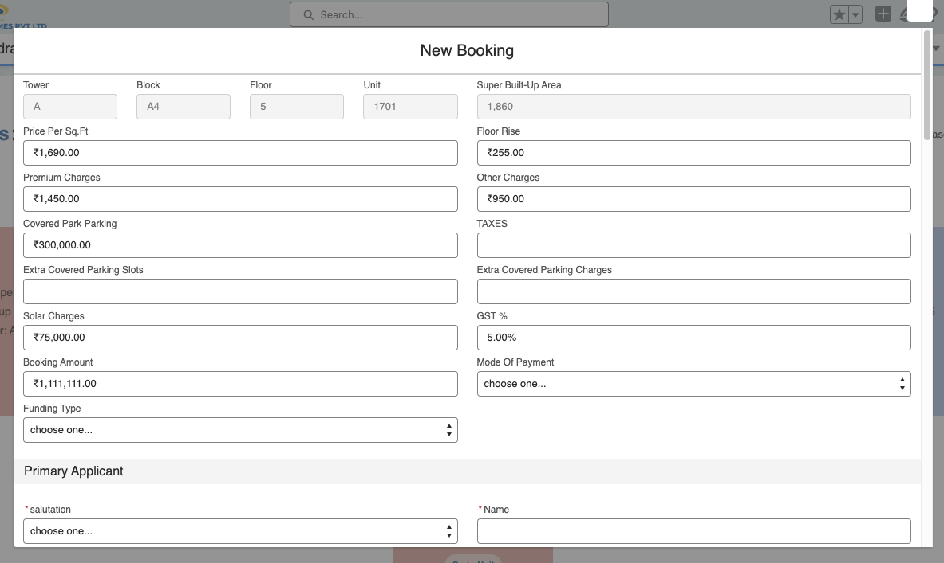
Appendix A : Booking Pop Up

Appendix B: Uploading the document
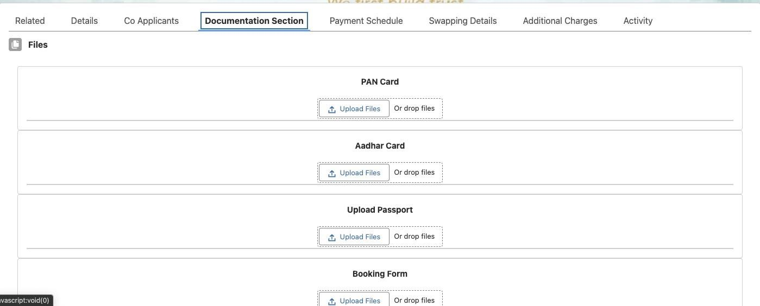

Appendix C : Receipts Map with the Booking

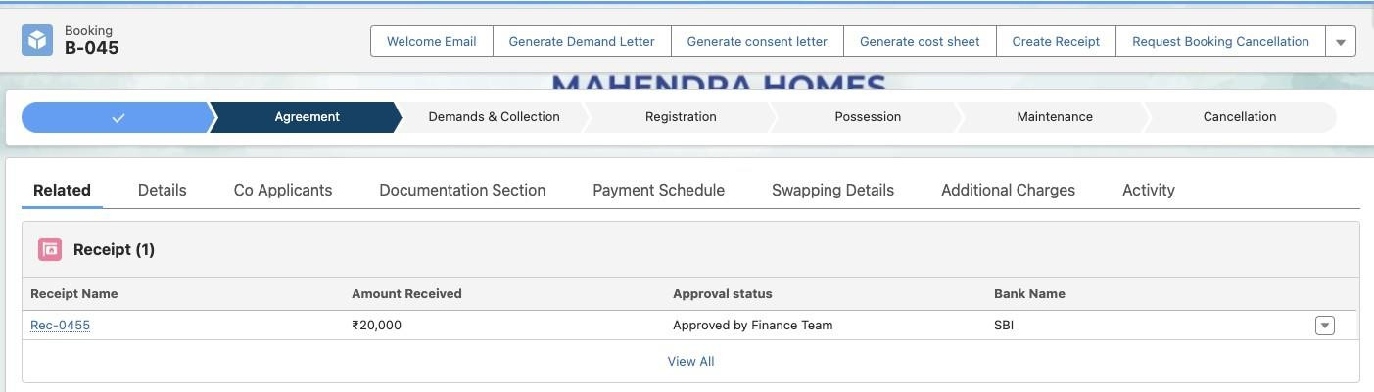

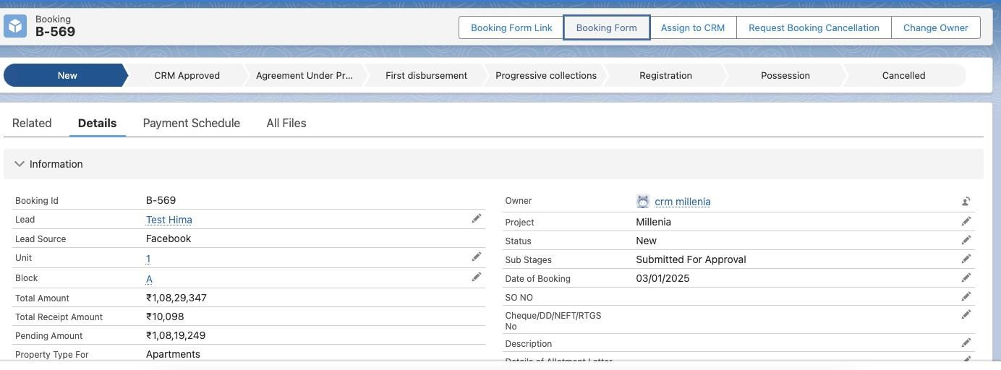
Appendix D: Generate Booking Form Button

Appendix E: welcome email and document Attached for reference only
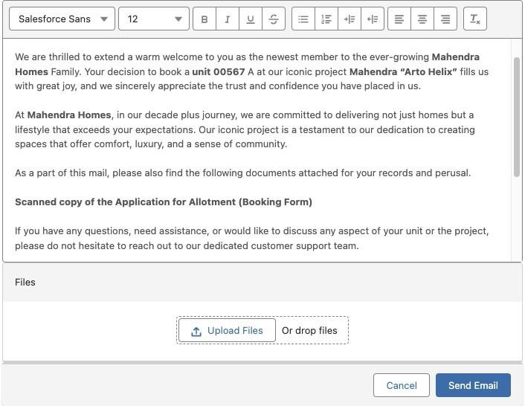

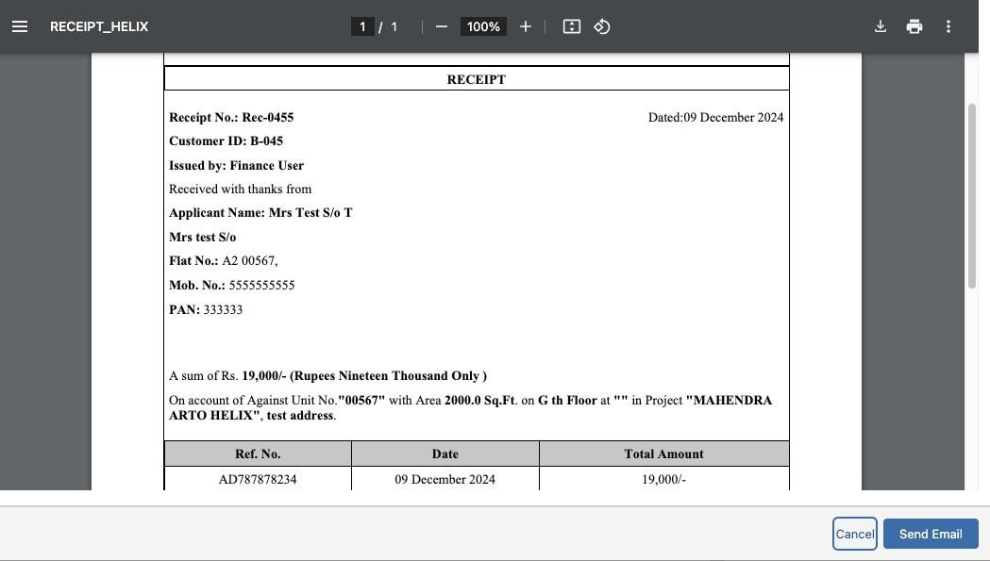
Appendix F: Receipt Detail and PDF for Reference only

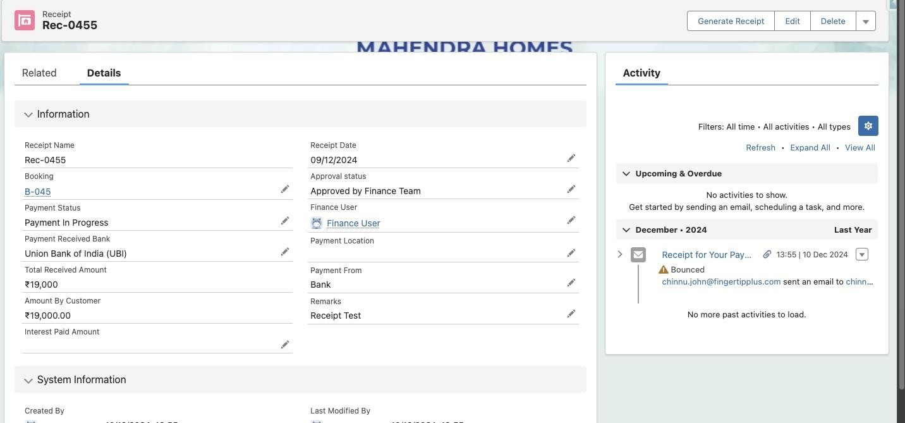

Ref to Appendix G: Individual demand rise PDF and Email.

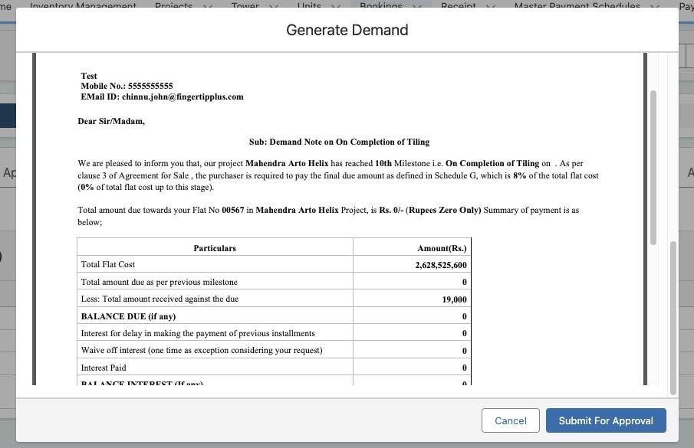

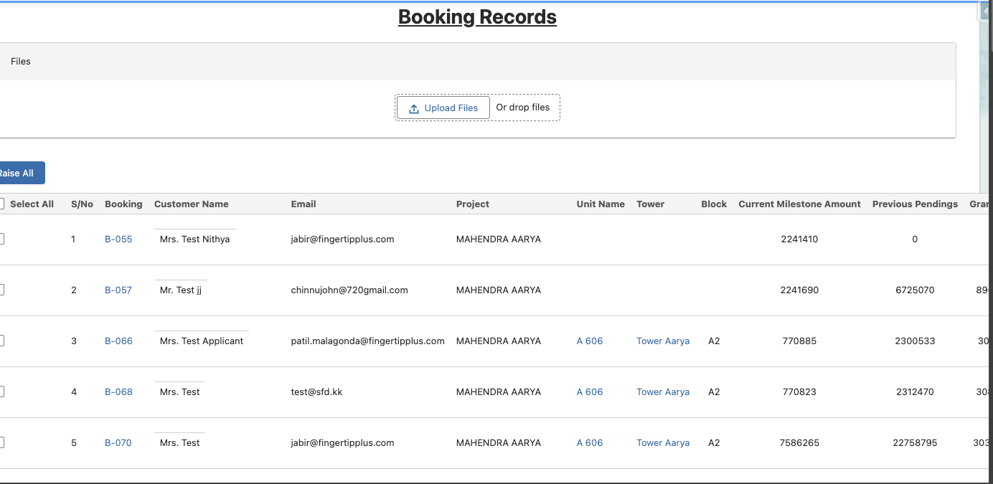
Appendix H : Bulk demands Rise PDF and Email.

Appendix I: Custom selection milestone Demand rise
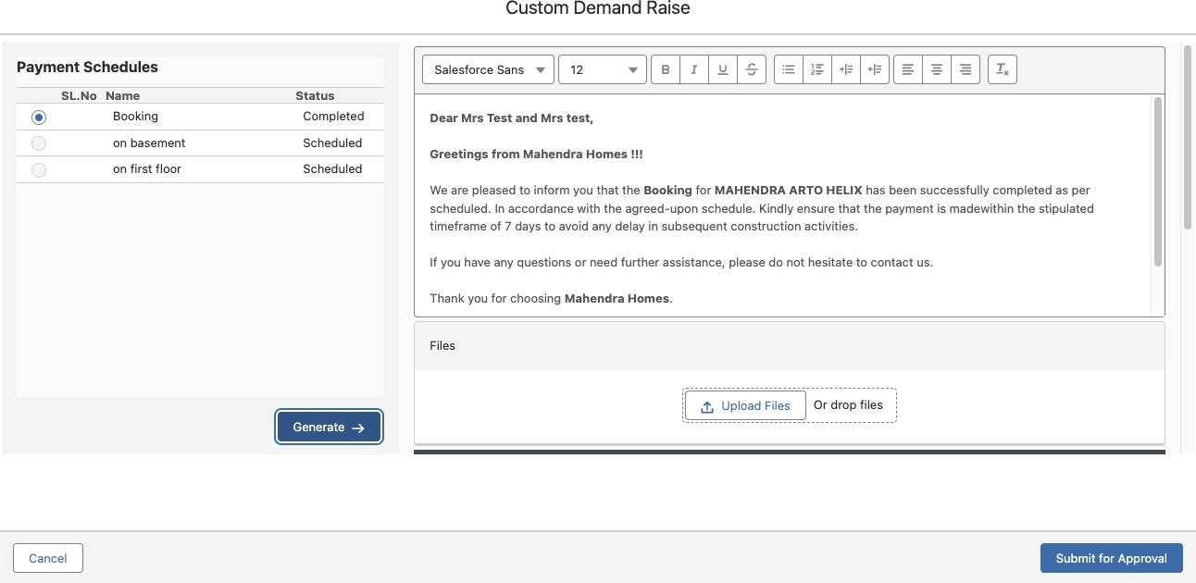

Appendix Q: Interest Calculation details

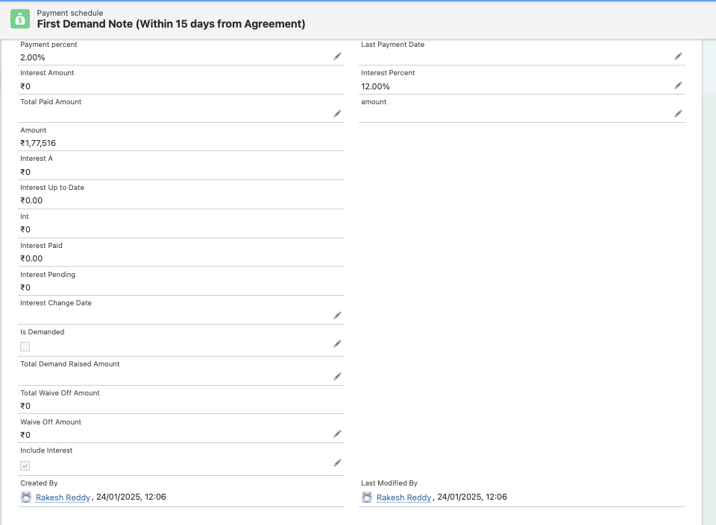

Important Notes:
  - Trifecta Team needs to share all the templates before the implementation begins. We will need to check on the count (Number of pages)
  - Confirm the existing data that needs to be uploaded to the salesforce before the GO LIVE.
  - Fingertip will provide the data template and Trifecta needs to fill the data against the template
  - Trifecta needs to share back the data template with filled data to complete the data upload process
  - Data cleaning will not be performed by FINGERTIP.
  - Data upload will be performed only once.
  - In case of any changes POST UAT or POST GO LIVE will be considered as change request and additional estimations and timeline will be applicable to implement

This is as per scope of work document:

Documentation

      - The document generations are considered only for one single format for all projects.
      - If any new projects add on, & any project specific documents need to be generated, the additional charges will be applicable per page.
      - The documents are considered up to 150 pages and all the documents are considered as PDF.
      - For any additional pages apart from 150 Pages, each page will be costing INR 500/- per each PDF pages
      - If any document needs to be generated in Word format, each page will cost INR 500 /- per page, if it is within 150-page limit.
      - For any additional pages apart from 150 Pages, each page will be costing INR 1000/- per each WORD pages

***End Of the Document***

